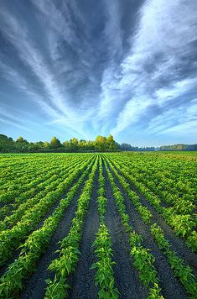

Mapping Pakistan's Agricultural Trade: Building a Provincial Statistics and Global Commodities Database for FABLE
A Data Pipeline for Pakistani Agricultural Production and Trade

By: Mohid Ali
Mentor: Syeda Baseerat Fatima

Summer Mentorship Program (SMP) 2026
Lahore University of Management Sciences (LUMS)
July 21, 2026

Abstract
Importance: Pakistan's agricultural sector supports the livelihoods of more than 40 percent of the country's population and accounts for roughly a quarter of GDP, yet the global modelling tools used to evaluate its food security and land-use futures still run, by default, on generic international estimates. The FABLE Calculator, developed by IIASA and SDSN, is one such tool: it projects national food systems to 2050, but its Pakistan inputs are drawn from FAOSTAT rather than from what Pakistan's own government agencies actually publish.
Research gap: No systematic effort had previously been made to replace FABLE's Pakistan defaults with data drawn directly from official Pakistani sources or to document, commodity by commodity, where and why those sources diverge from international estimates. As a result, FABLE-based analyses for Pakistan have been calibrated on figures that, for certain years and commodities, reflect FAO estimation methodology rather than reported statistics.
Objectives: This project aimed to build a reproducible, source-critical data pipeline that replaces FABLE's generic Pakistan inputs with provincial production statistics and Comtrade-based trade data; to quantify and explain the divergence between those figures and FAOSTAT; and to integrate the corrected data directly into the FABLE Calculator workbook.
Methodology: Provincial crop and livestock production was compiled from multiple editions of Pakistan's Agricultural Statistics publications and Fruit, Vegetables and Condiments Statistics. National trade data was drawn from UN Comtrade for 2000 through 2025 and mapped to FABLE categories through a 530-plus-entry tariff-code concordance table. The pipeline was validated against 7,904 comparable FAOSTAT data points and the corrected five-year-average trade figures were then integrated into the FABLE Calculator workbook, repairing a critical formula disconnection in the process.
Key findings: Applying a systematic revision-boundary check to the concordance table recovered close to five billion US dollars of trade across twelve commodities that had been returning zeros because the concordance contained only post-2012 tariff codes. Cotton lint exports were found to have been systematically overstated by a byproduct code unrelated to primary production. Agreement with FAOSTAT is strong from 2011 onward but diverges before that year because FAOSTAT relied on its own estimates rather than reported customs data in the earlier period. A structural formula disconnection in the FABLE Calculator was identified and corrected; without this fix, every future trade data update would have had no effect on the model's outputs.
Implications: The corrected dataset reveals that Pakistan's transition from net agricultural exporter to net importer is more gradual than previously modelled, and that the model's 2008 wheat import spike, reflecting real emergency procurement during the global food-price crisis, was entirely absent from the uncorrected series. The concordance table requires maintenance at every future Harmonized System revision cycle, and ten commodities currently absent from the FABLE Calculator's product table represent the highest-priority candidates for model extension.

Contents
1 Introduction 4
2 Data Sources 4
3 FABLE’s 76 Commodities 5
4 Building the Provincial Production Dataset 8
5 The Concordance Table 9
6 Building the Trade Dataset 10
7 Joining Production and Trade 11
8 Validating Against FAOSTAT 13
9 Limitations 14
10 Interim Conclusion 15
11 A Five-Year-Average Trade Dataset for the FABLE Calculator 16
12 Integrating the Trade Data into the FABLE Calculator 16
13 Results of the FABLE Calculator Integration 17
14 Conclusion 19

1 Introduction
FABLE runs as ten linked calculation steps inside a single spreadsheet — consumption, livestock production, crop production, land use, and finally trade and food-security indicators — and it was built to work for any country using the same generic FAOSTAT inputs. Pakistan, however, does publish its own detailed agricultural statistics every year, at the provincial level, and those numbers do not always agree with what FAOSTAT reports for the same crop and year. This project’s job was to close that gap: replace FABLE’s Pakistan inputs with data pulled directly from Pakistan’s own sources, and check how the result compares to FAOSTAT so the difference is understood rather than just assumed away.
The work was completed over four weeks as part of the 2026 Summer Mentorship Program at LUMS. It moved through several connected stages: matching FABLE’s own commodity list against what Pakistan actually produces and trades, building a provincial production dataset, building a national trade dataset through a tariff-code concordance table, joining the two into a single balance table, and validating the result against FAOSTAT. Each stage is covered in turn below.

2 Data Sources
Table 1 lists the main sources used. Production figures come almost entirely from Pakistan’s own agricultural and horticultural statistics, and trade figures come from UN Comtrade. FAOSTAT is used only as the baseline the trade dataset is checked against at the end of the pipeline, never as a source for filling gaps earlier in it.
Category | Sources
Crop production | MINFAL Agricultural Statistics of Pakistan (ASP), 2021-  22 and 2023-24 editions; PBS Agricultural Statistics of Pakistan 2010-11; PBS District-Wise Crops, 2022-23 and 2024-25 editions.
Fruit, vegetable and condiment produc-  tion | Fruit, Vegetables and Condiments Statistics of Pakistan (FVC), five editions spanning 2008-09 through 2023-24.
Livestock produc-  tion | ASP Tables 122–125 (milk, meat and eggs, other livestock products, fish), 2021-22 and 2023-24 editions.
Trade flows | UN Comtrade, queried with Pakistan as reporter.
Conversion factors | FAO Technical Conversion Factors (Pakistan); FAO Food Balance Sheets Handbook; ICCO cocoa statistics; IRRI rice-milling data; USDA Agricultural Handbook 697; FAO/JECFA’s guar gum assessment; industry references for smaller commodities.
Validation baseline | FAOSTAT, Trade: Crops and Livestock Products domain.
Table 1: Main data sources used in the pipeline.

3 FABLE’s 76 Commodities
FABLE classifies the global food system into 76 individual commodities, grouped into 19 broader categories such as cereals, oilseeds, pulses, and livestock products. Before any data could be collected, each of these 76 had to be checked against what Pakistan actually produces and matched to the Pakistani publication, or combination of publications, that could supply it. Table 2 lists all 76, grouped the way FABLE groups them, together with how each was ultimately classified: whether direct provincial data exists in an official Pakistani publication, whether the figure has to be built by summing several Pakistani crops together, whether it can only be reached by applying a conversion factor to a related raw material, or whether Pakistan does not produce or trade it at all.
This classification was the starting point for the production dataset, not a guarantee. A few commodities initially expected to have usable data turned out, once the actual publications were checked line by line, to have no separate series after all; these cases are noted again in the limitations at the end of this report.

# | Commodity | Group | Classification
1 | Wheat | Cereals | Available
2 | Rice (paddy) | Cereals | Available
3 | Corn / Maize | Cereals | Available
4 | Millet | Cereals | Available
5 | Sorghum | Cereals | Available
6 | Barley | Cereals | Available
7 | Oats | Cereals | Not applicable
8 | Rye | Cereals | Not applicable
9 | Other cereals | Cereals | Not applicable
10 | Sugar cane | Sugar | Available
11 | Sugarbeet | Sugar | Available
12 | Sugar raw | Sugar | Needs conversion factor
13 | Cotton lint | Fibre & Industrial | Available
14 | Jute | Fibre & Industrial | Available
15 | Rubber | Fibre & Industrial | Not applicable
16 | Other hard fibers | Fibre & Industrial | Not applicable
17 | Other soft fibers | Fibre & Industrial | Not applicable
18 | Cotton (seed) | Oilseeds | Available
19 | Rapeseed | Oilseeds | Available
20 | Sesame | Oilseeds | Available
21 | Sunflower | Oilseeds | Available
22 | Oil palm fruit | Oilseeds | Not applicable
23 | Olive | Oilseeds | Not applicable
24 | Soybean oil | Oilseeds | No local data
25 | Coconut oil | Oilseeds | Needs conversion factor
26 | Groundnut oil | Oilseeds | Needs conversion factor
27 | Palm oil | Oilseeds | Not applicable
28 | Other oils | Oilseeds | Built by summing crops
29 | Cotton cake | Oilseed Cake | Needs conversion factor
30 | Groundnut cake | Oilseed Cake | Needs conversion factor
31 | Rapeseed cake | Oilseed Cake | Needs conversion factor
# | Commodity | Group | Classification
32 | Other oilseed cake | Oilseed Cake | Needs conversion factor
33 | Gram / Chickpea | Pulses | Available
34 | Mung bean | Pulses | Available
35 | Lentil / Beans | Pulses | Available
36 | Peas | Pulses | Available
37 | Other pulses | Pulses | Built by summing crops
38 | Potato | Roots & Tubers | Available
39 | Sweet potato | Roots & Tubers | Available
40 | Cassava | Roots & Tubers | Not applicable
41 | Yams | Roots & Tubers | Not applicable
42 | Other tubers | Roots & Tubers | Not applicable
43 | Apple | Fruit & Vegetables | Available
44 | Banana | Fruit & Vegetables | Available
45 | Coconut | Fruit & Vegetables | Available
46 | Date | Fruit & Vegetables | Available
47 | Grape | Fruit & Vegetables | Available
48 | Grapefruit | Fruit & Vegetables | No local data
49 | Lemon | Fruit & Vegetables | No local data
50 | Onion | Fruit & Vegetables | Available
51 | Orange (Citrus) | Fruit & Vegetables | Available
52 | Pineapple | Fruit & Vegetables | Not applicable
53 | Plantain | Fruit & Vegetables | Not applicable
54 | Tomato | Fruit & Vegetables | Available
55 | Other citrus | Fruit & Vegetables | Built by summing crops
56 | Other fruits | Fruit & Vegetables | Built by summing crops
57 | Other vegetables | Fruit & Vegetables | Built by summing crops
58 | Nuts | Nuts | Available
59 | Tobacco | Beverages & Spices | Available
60 | Tea | Beverages & Spices | Not applicable
61 | Cocoa | Beverages & Spices | Not applicable
62 | Other spices | Beverages & Spices | Built by summing crops
63 | Fish | Fish | Available
64 | Butter / Ghee | Animal Fat | Available
65 | Cream | Animal Fat | No local data
66 | Raw animal fat | Animal Fat | Available
67 | Eggs | Eggs | Available
68 | Milk | Milk | Available
69 | Poultry meat | Poultry | Available
70 | Beef | Red Meat | Available
71 | Goat & Lamb | Red Meat | Available
72 | Pork | Pork | Not applicable
73 | Offal | Other | No local data
74 | Beer | Alcoholic Beverages | Not applicable
(continued)

(continued)
# | Commodity | Group | Classification
75 | Wine | Alcoholic Beverages | Not applicable
76 | Other alcoholic bev. | Alcoholic Beverages | Not applicable
Table 2: FABLE’s 76 commodities, grouped by category, and how each was classified for the production dataset.

4 Building the Provincial Production Dataset
The production dataset covers 42 of FABLE’s 76 commodities across Punjab, Sindh,
Khyber Pakhtunkhwa, Balochistan and a national total, for fiscal years 2000-01 through
2024-25. Every commodity follows the same six-column layout regardless of how complete its data is, and a missing year is always written as the literal string “no data” rather than estimated or left blank, so a gap looks like a gap and not like a zero.
Most crop figures come from Pakistan’s Agricultural Statistics publications. A handful of commodities, including peas, sweet potato, coconut, and a few composite categories such as “Other fruits” and “Other vegetables,” only appear in a separate horticultural survey published in five-year windows across five editions. Where a crop appears in both sources for overlapping years, the newer edition was used only to cross-check the existing figures rather than replace them, since later editions occasionally bundle several named crops into a single combined line for a given province, which can make a real crop look like it produced nothing that year if taken at face value. Where a crop genuinely only appears in one source, that source was used directly.
A few of FABLE’s commodities are composites, built by summing several Pakistani crops together — rice combines two locally tracked varieties, for instance, and several “Other” categories sum minor crops that Pakistan reports individually but FABLE groups together. These groupings were fixed once at the start and applied consistently.
Three unit decisions are worth noting here. Cotton lint was reported in bales and converted to tonnes using Pakistan’s standard bale weight. Eggs were reported as a count and converted to a weight basis using an average egg weight, since FABLE’s own balance table works in tonnes for every commodity and a count cannot be joined against trade figures reported by weight. And a labelling error in three sheets had them recorded in raw tonnes instead of the workbook’s standard unit of thousands of tonnes, which first became obvious as an implausible national total for one of the affected crops.
A set of Python scripts was built to standardise every sheet into this format: enforcing consistent units, checking that the four provincial figures sum to the national total for each year, and flagging any row where they do not. This makes the dataset something that can be regenerated and re-checked directly from its sources, rather than relying on one-off manual edits that would be hard to retrace later.
Figure 1 shows a finished sheet from the production dataset, including the automated province-sum check column described above.
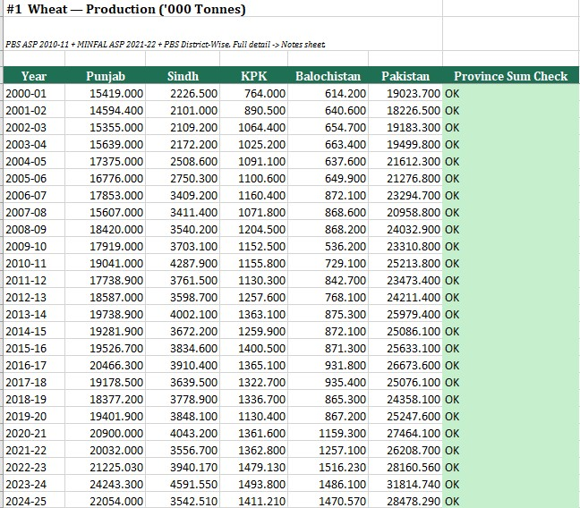
Figure 1: A finished commodity sheet from the production dataset, with the automated province-sum check column on the right.

5 The Concordance Table
Every good that crosses Pakistan’s border is recorded against a six-digit tariff code under the Harmonized System (HS), the same classification customs authorities everywhere use. FABLE, on the other hand, groups commodities by FAO item code, and the two classifications do not line up in any simple way — a single FABLE commodity can correspond to several HS codes, and a single HS code sometimes has to be split across more than one FABLE commodity, or left out altogether. Before any trade figures could be pulled, this translation between the two systems had to be worked out in full and written down in one place: the concordance table.
For every HS code that might plausibly belong to a FABLE commodity, the concordance records one of four actions. Some codes are included exactly as reported. Others are excluded entirely, either because they describe a manufactured product rather than a primary crop, because including them would double-count something already captured elsewhere, or because they belong to a different FABLE commodity. A third group needs a conversion factor before it can be added in at all, because the form Pakistan actually trades is not the form FABLE expects — milled rice rather than paddy, cocoa butter rather than cocoa beans, a live animal rather than a carcass. A final small group covers commodities Pakistan trades in genuinely negligible or zero quantity.
Conversion factors needed real sourcing rather than a rough guess, since the wrong factor distorts a commodity’s entire trade figure. Where possible, a factor was taken from an authority specific to that commodity: FAO’s own conversion tables for milling and livestock yields, the International Cocoa Organization for cocoa products, IRRI for rice, and industry references for smaller commodities such as guar gum, whose conversion factor went unsourced for a long stretch of the project before an appropriate industry reference was found. A small number of factors remain honest estimates rather than fully verified figures, and are labelled as such.
Figure 2 shows a section of the finished concordance table, with each HS code’s action — include, exclude, or convert — colour-coded for quick reading.
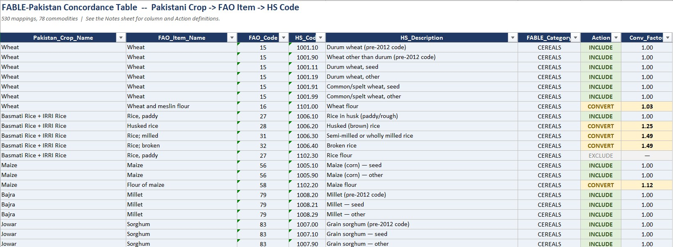
Figure 2: A section of the finished concordance table, mapping Pakistani crop names through FAO item codes to individual HS tariff codes.

6 Building the Trade Dataset
Trade figures were pulled from UN Comtrade for every tariff code the concordance marks as includable or convertible, covering both import and export flows from 2000 through 2025. Pakistan filed no reporter submission at all for 2000 through 2002, so those three years were reconstructed instead from partner countries’ own records — what every other country reported trading with Pakistan, with the flow direction reversed.
Figure 3 shows one commodity’s finished trade sheet: value and quantity for both import and export flows, summed across every tariff code that maps to it.
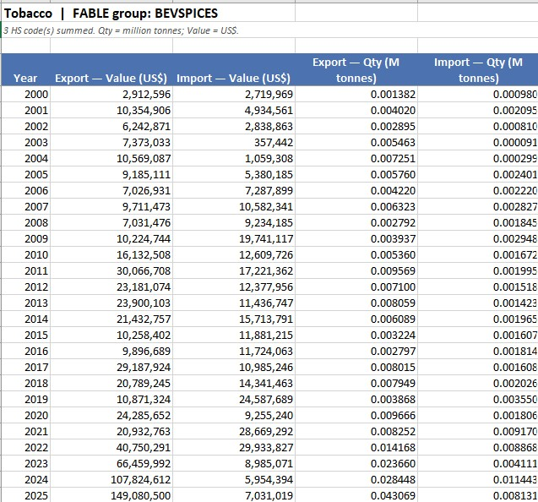
Figure 3: A finished commodity sheet from the aggregated trade dataset.
The most significant finding at this stage was that the Harmonized System itself gets revised periodically — in 2002, 2012, 2017 and 2022 across the years this project covers — and old tariff codes are retired and replaced at each revision. Comtrade answers a query using whichever version of the code system was in force that year, so a retired code returns normal-looking trade right up to the revision and then an exact zero afterward,
which is indistinguishable from a real absence of trade unless it is specifically checked for. This is how Pakistan’s kino (mandarin) exports, its single largest fruit export, appeared to collapse to almost nothing from 2017 onward: the tariff code it had been mapped to was split into three new codes that year, and the concordance was never updated to follow. The same check, applied systematically across every revision boundary rather than just this one case, turned up a much larger gap: the concordance had been built almost entirely from codes introduced by the 2012 revision, so an entire cluster of commodities — Wheat foremost among them — was running on codes that simply did not exist for 2003 through 2011, years that include two of FABLE’s own calibration points. Restoring the missing codes recovered close to five billion dollars of trade across a dozen commodities.
A second, unrelated problem surfaced in Cotton lint, whose export total had been dominated for years by a tariff code describing cotton waste recovered during yarn spinning — a manufacturing byproduct, not something a cotton grower produces — which had inflated its official export figure several times over. Both problems are corrected in the finished trade dataset.
Figure 4 shows what the kino tariff-code fix did to the numbers.
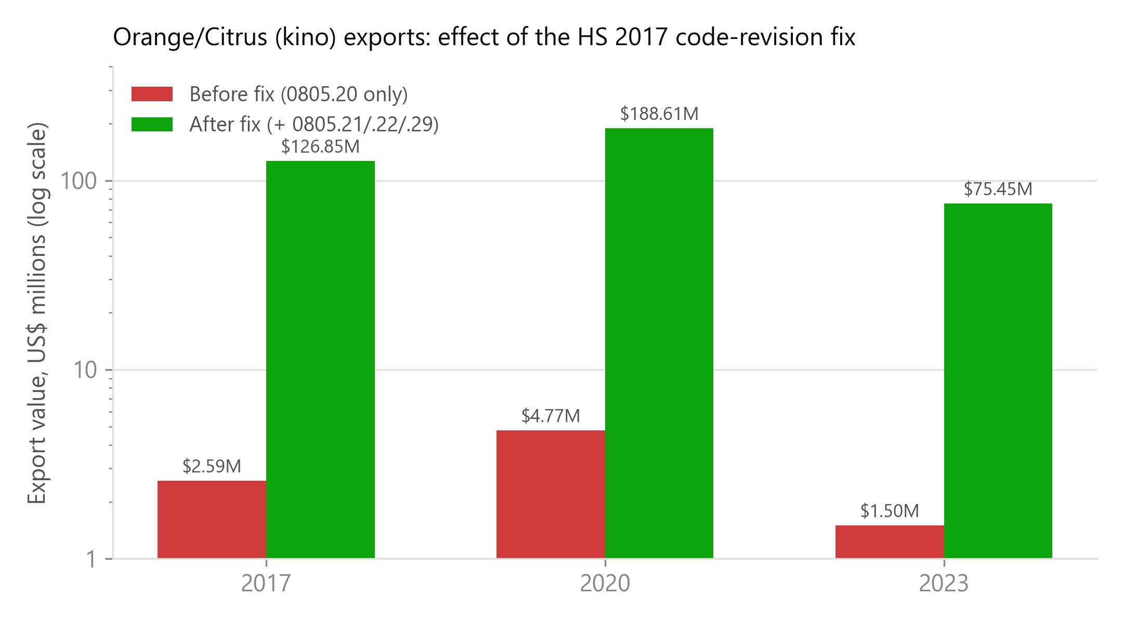
Figure 4: Orange/Citrus export value before and after adding the 2017 tariff-code successors for kino.

7 Joining Production and Trade
The finished production dataset and the finished trade dataset are joined into one national balance table — production plus imports minus exports — for every FABLE commodity, every year. Two things had to be resolved first. The two datasets identify commodities differently under the hood: production sheets are named after the commodity, while the trade side groups by tariff-code mapping, and joining on the name alone silently dropped five commodities whose names contain a forward slash, a character Excel does not allow in a sheet title. And production is reported by Pakistani fiscal year while trade is reported by calendar year, so each fiscal year was mapped to its first calendar year, matching the convention FAOSTAT itself uses for Pakistani crop years.
The balance is only calculated when production, imports and exports are all genuinely present for that commodity and year; a missing value is never assumed to be zero. The result is a complete 76-commodity by 26-year grid, so any gap in coverage shows up directly in the table.
Figure 5 shows this table in practice for Wheat.
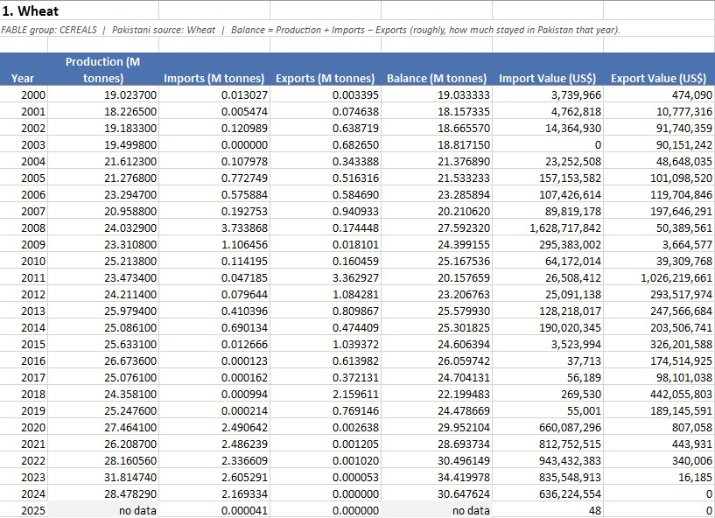
Figure 5: Wheat’s finished sheet in the joined production–trade balance table.
The same series is plotted in Figure 6, including the spike in 2008 that reflects real wheat imports during that year’s global food-price crisis — a spike that only appears because of the tariff-code fix described in the previous section; the original, unrevised trade pull had missed almost all of it.
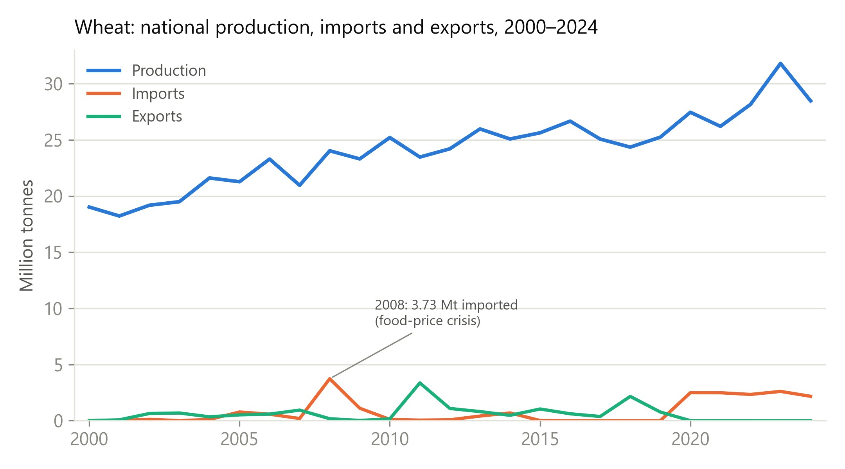
Figure 6: Wheat’s national production, import and export series in the final joined dataset.

8 Validating Against FAOSTAT
The last stage compares the project’s trade figures against FAOSTAT’s published Pakistan trade data, commodity by commodity and year by year, across export and import value and quantity — 7,904 comparable cells in total.
Figure 7 shows one commodity’s finished validation sheet, with each percentage difference colour-coded and a short written note explaining the pattern for that commodity.
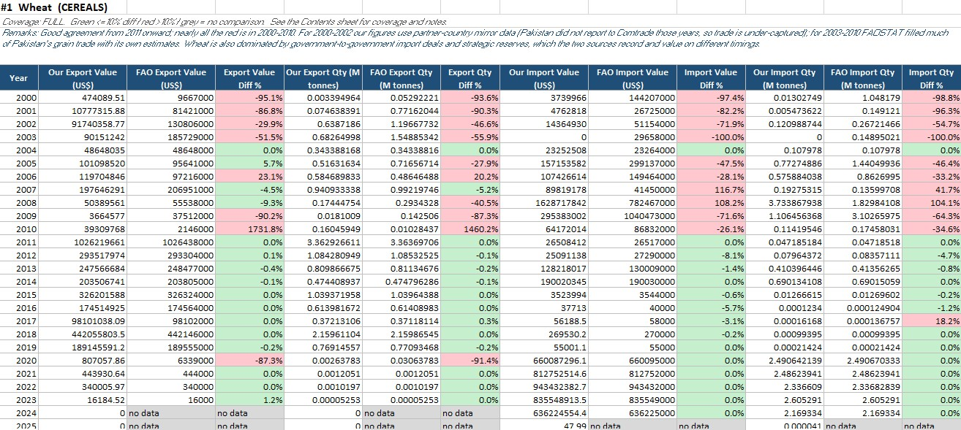
Figure 7: Wheat’s finished validation sheet, comparing the project’s trade figures against FAOSTAT year by year.
Building this comparison also helped catch mistakes made earlier in the pipeline. Several commodities that looked badly mismatched against FAOSTAT turned out, on closer inspection, to be mapped incorrectly on this project’s own side rather than genuinely different from FAOSTAT’s figures — a reference code pointing at the wrong FAOSTAT item in one case, a comparison against the wrong form of a converted product in another. Correcting these moved several major commodities from mostly disagreeing with FAOSTAT to matching it closely.
After every correction, a majority of comparable cells land within ten percent of FAOSTAT’s own figure. That share is not spread evenly across the years, though, and understanding why turned out to matter. Agreement is low and inconsistent through
2010, then settles into a stable, much higher range from 2011 onward, as Figure 8 shows.
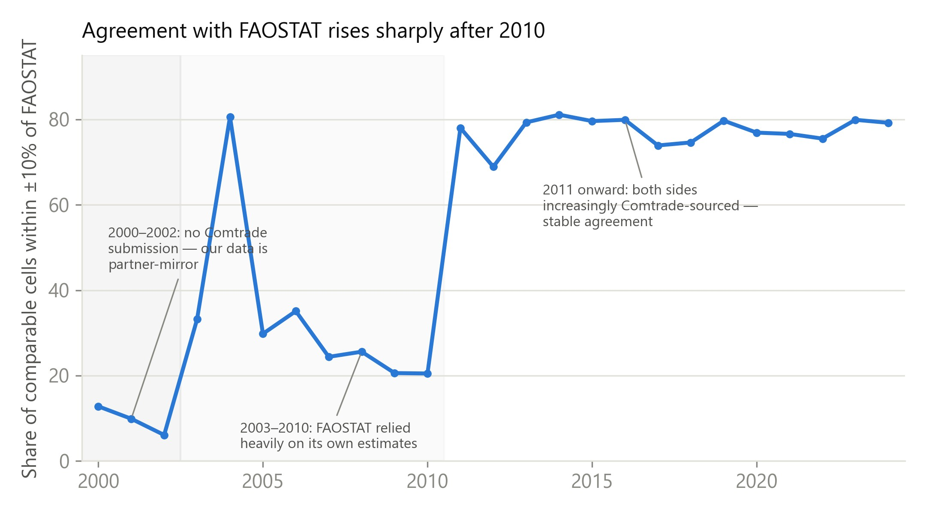
Figure 8: Share of comparable cells matching FAOSTAT within ±10%, by year.
The 2000–2002 years reflect a genuine limitation on this project’s own side: Pakistan filed nothing with Comtrade in those years, so the figures for that period had to be reconstructed from partner-country records, which tend to undercount. The 2003–2010 years are closer to the reverse situation — FAOSTAT’s own published data-quality indicators show that a large share of Pakistan’s trade rows in that window were estimated rather than drawn from actual customs records, a share that falls close to zero from
2014 onward. From 2011 on, both sources increasingly draw from the same underlying Comtrade data, which is why they converge. This points to a conclusion worth stating plainly: the early-year gap should not be closed by adjusting this project’s own figures to match FAOSTAT’s for that period, since those figures are the less reliable side of the comparison for that stretch of years, not the other way round.
A smaller set of mismatches reflect a genuine difference in scope rather than an error on either side — one vegetable category, for example, includes garlic, which Pakistan imports in real volume but which FAOSTAT tracks under no item at all, so that comparison will always run high on one side. Cases like this are documented individually in the validation output.

9 Limitations
This dataset is only as complete as Pakistan’s own published statistics allow. Livestock products — milk, beef, mutton, poultry, eggs and animal fat — have no provincial breakdown in any source checked, so every livestock figure here is a national total. A handful of year ranges remain unfillable with the sources currently available, most notably livestock data for 2011-12 through 2017-18, where the available editions simply do not print those years. A few conversion factors, including one for rice flour and one catch-all milk-powder category, are honest estimates rather than fully verified figures, and are labelled as such. A small number of real Pakistani trade flows, including pepper, sit outside FABLE’s own commodity classification entirely and would need a decision on where they belong before being added. And, as noted in Table 2, three commodities — cotton seed, butter and ghee, and one citrus sub-category — were initially expected to have usable production data, but turned out, once the actual publications were checked, to have no separate series after all.

10 Interim Conclusion
This project set out to give FABLE a Pakistan-specific alternative to its default FAOSTAT inputs, and to understand where and why the two would disagree once that alternative existed. Both parts of that goal were met: a production dataset and a trade dataset covering most of FABLE’s 76 commodities across 25 years, joined into one balance table and checked line by line against FAOSTAT. The more lasting lesson from the process, though, is how many of the biggest findings came down to simply not accepting a plausiblelooking number without checking it first — a zero that turned out to be a retired tariff code, a total dominated by a byproduct rather than the product it claimed to be, a join that silently dropped a fifth of its matches. None of these looked wrong from the outside. That habit of double-checking, more than any single figure in this dataset, is what carries forward into whatever comes next.

11 A Five-Year-Average Trade Dataset for the FABLE Calculator
The trade dataset described in Section 6 covers the full annual series from UN Comtrade, but FABLE does not calibrate on an annual series. Its historical inputs are anchored to five fixed benchmark years: 2000, 2005, 2010, 2015, and 2020. A separate aggregation step therefore collapsed the annual series into five-year window averages, one centred on each benchmark year, producing the file FABLE Trade FiveYear Averages.
Each window average is computed only from years for which real reported data exists; no zero-padding is applied when a year within a window is missing. The year 2025 is deliberately excluded from the averages despite appearing in the Comtrade pull, because FABLE treats 2025 as a forward projection rather than a historical calibration anchor. The five-year averaging also dampens the effect of genuine single-year anomalies such as drought-year shortfalls, emergency import spikes, or temporary policy-driven surges that would otherwise distort the calibration baseline.

12 Integrating the Trade Data into the FABLE Calculator

12.1 Unit conversion
The five-year-average trade file expresses quantities in million tonnes and values in US dollars, while the FABLE Calculator’s TRADE sheet requires quantities in units of 1,000 tonnes and values in 1,000 USD. Every figure was therefore multiplied by 1,000 for quantities, or divided by 1,000 for values, before being written into the relevant columns: P for exports quantity, Q for imports quantity, D for exports value, and E for imports value. A unit mismatch at this stage would have scaled every trade figure by three orders of magnitude in the wrong direction.

12.2 Commodity mapping and coverage
Of FABLE’s 76 commodities, 58 were successfully mapped to corresponding rows in the FABLE Calculator’s TRADE sheet. Ten commodities could not be linked because they have no matching product line in the current model structure; connecting them would require adding new rows to the sheet, which is beyond the remit of this project. Eight further commodities matched a FABLE product row but had no real Comtrade data for any of the five benchmark periods, so the model’s default values were left in place for them.

12.3 The critical formula disconnection
The EXPORTS and IMPORTS columns in the model’s core balance table are located in the 1_data_demand sheet, under the prod_balance table, in columns V and W — the cells that ultimately feed FABLE’s TRADE sheet results. Integrating the five-year-average figures into these cells required resolving two technical problems, discovered only during the integration process itself, affecting two groups of cells in the Pakistan workbook examined, designated UP49 and UP51. In UP49, the formulas were pointing to a dead external SharePoint file reference that resolved to nothing. In UP51, the cells contained hardcoded, static numbers from some earlier data pull, carrying values that were disconnected from the FAO product code sheet entirely. In both cases the practical effect was identical: any update to the FAO product code sheet, however carefully executed, would never propagate through to the TRADE results that the model actually reports.
All 500 affected cells across both workbook versions were converted to live formulas referencing the FAO product code sheet directly, using the same offset logic as every other column in the table. The four MILK rows that had been manually overridden and noted as intentional exceptions were identified and left untouched. Without this fix, the entire trade data update would have been structurally correct, numerically accurate, properly unit-converted, and completely invisible to the model’s outputs.

13 Results of the FABLE Calculator Integration
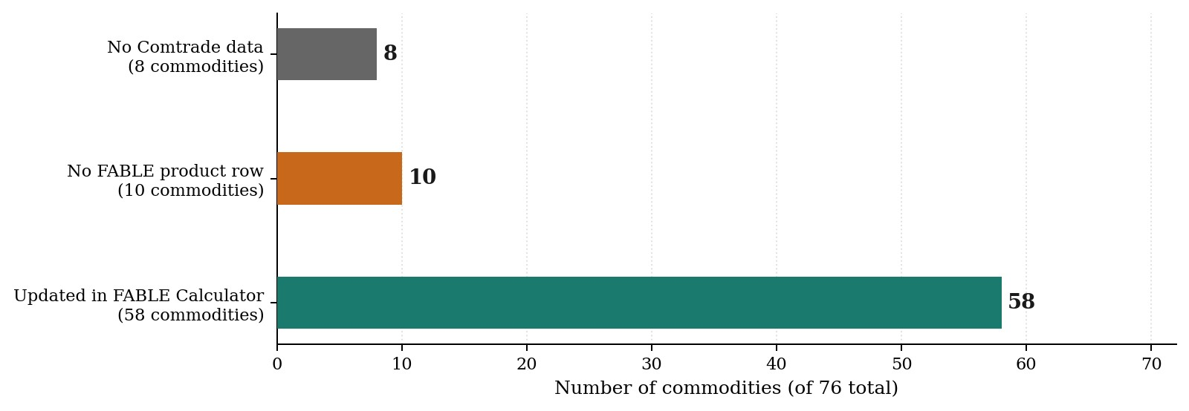
Figure 9: Commodity coverage for the Comtrade data integration. Of FABLE’s 76 commodities, 58 were updated with real five-year-average trade figures; 18 were excluded, with fully documented reasons.
Table 2 and Figures 10 and 11 present the model’s aggregate trade results, summed across all products, before and after the Comtrade data integration, as read directly from the FABLE Calculator's TRADE sheet. The Before figures represent a snapshot captured immediately prior to the update; the After values come from live formulas re-reading FAO prod c following the integration.
Year | Exp. Before | Exp. After | Imp. Before | Imp. After | Bal. Before | Bal. After
2000 | 2,797,526 | 1,924,103 | 1,393,041 | 1,267,640 | 1,404,484 | 656,462
2005 | 6,598,118 | 4,346,114 | 1,922,322 | 2,153,912 | 4,675,797 | 2,192,201
2010 | 3,203,422 | 3,434,753 | 3,142,402 | 2,551,237 | 61,020 | 883,516
2015 | 2,173,972 | 2,646,233 | 4,022,759 | 3,478,925 | -1,848,788 | -832,692
2020 | 1,528,329 | 2,186,783 | 4,544,087 | 4,673,957 | -3,015,759 | -2,487,174
2025 | 1,261,598 | 1,710,459 | 2,182,449 | 2,590,817 | -920,851 | -880,358
2030 | 1,401,424 | 1,884,332 | 2,323,356 | 2,758,008 | -921,932 | -873,676
2040 | 1,684,450 | 2,233,177 | 2,576,511 | 3,058,185 | -892,061 | -825,008
2050 1,968,940 2,582,491 2,790,443 3,311,675 -821,503 -729,184
Table 2: FABLE Calculator total trade results (US$ thousands, all products) before and after the Comtrade data integration. Values from 2025 onward reflect the model's forward extrapolation from the updated calibration baseline.
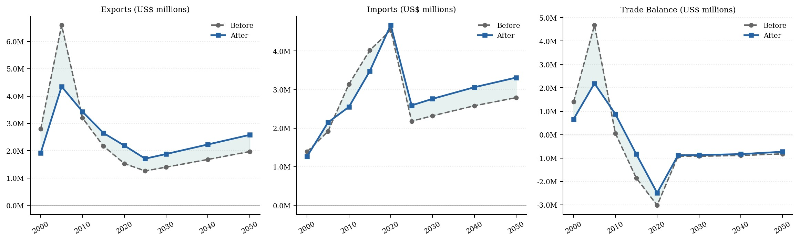
Figure 10: Exports, imports, and trade balance before (dashed) and after (solid) the Comtrade data update. Values in US$ millions. The shaded areas indicate the net change introduced by the integration.
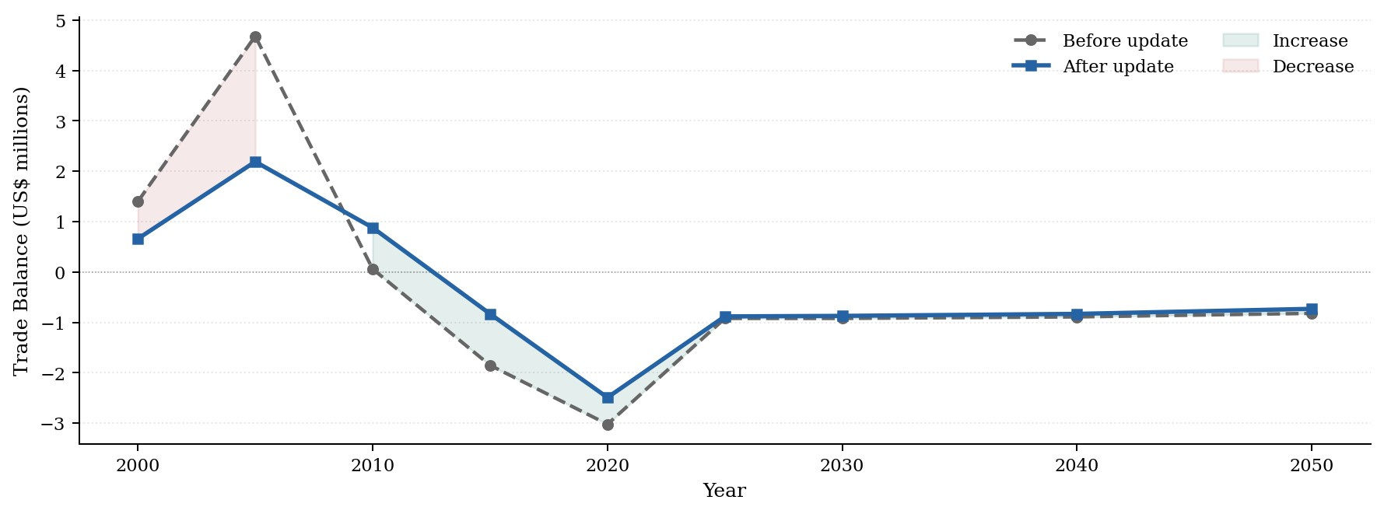
Figure 11: Total trade balance trajectory before and after the update. Green shading indicates increase relative to pre-update figures; red shading indicates decrease.

13.1 Interpreting the shifts
The export reduction in 2000 to 2005 is primarily explained by the Cotton lint byproduct exclusion. The pre-update series was inflated by a tariff code for cotton waste recovered during yarn spinning, which dominated the official export total in those years. Removing that code brought the export series into line with what cotton growers actually shipped.
The import and export recovery visible around 2010 reflects the HS revision fix, which restored trade flows across twelve commodities that had been returning zeros because the concordance contained only post-2012 codes. The 2008 wheat import spike of 3.73 million tonnes, representing real emergency procurement during the global food-price crisis, appears in the corrected series for the first time.
The corrected data shows Pakistan's transition from net exporter to structural net importer as more gradual than the pre-update figures suggested. The 2015 to 2020 deficit is smaller in the after scenario because the inflated export base has been removed. Projected years from 2030 onward shift because FABLE's forward extrapolation is anchored to its calibration-year values, and the corrected 2020 baseline propagates forward through the model.

14 Conclusion
When this project began, FABLE's Pakistan inputs were generic FAOSTAT defaults: internationally compiled estimates that, while adequate for broad comparative purposes, could not reflect what Pakistan's own statistical agencies report at the provincial level, nor capture how Pakistani commodities move through global trade classifications. The project set out to replace those defaults with data grounded in official Pakistani sources, and to do so in a way that was traceable, reproducible, and honest about where gaps remained.
By the time the pipeline reached the FABLE Calculator workbook, it had built a provincial production dataset covering 42 commodities across four provinces and 25 fiscal years; a national trade dataset spanning 76 commodities and 26 years, constructed through a 530-plus mapping concordance table cross-referencing Harmonized System codes, FAO item codes, and FABLE categories; and a full validation pass against 7,904 comparable FAOSTAT data points, with interpretive notes explaining the pattern of agreement and divergence for each commodity. The subsequent integration into the FABLE Calculator workbook, updating trade inputs for 58 of 76 commodities and repairing 500 formula cells that had been preventing trade data from reaching the model's outputs, produced the first version of the FABLE-Pakistan tool calibrated on real Pakistani data.
Several findings from this project deserve to be understood as structural observations rather than one-time corrections. The formula disconnection in the FABLE Calculator would have caused any future trade data update to have zero effect on the model's reported results, regardless of how carefully the FAO prod c sheet was updated. This is not merely a data problem that has now been fixed; it is a structural characteristic of the workbook that requires active verification whenever the model is updated in the future. Similarly, the concordance table requires maintenance at every future Harmonized System revision boundary. The five-billion-dollar trade recovery documented in this

References
- FABLE Consortium, Pathways to Sustainable Land-Use and Food Systems: 2020 Report. IIASA and SDSN. Available at: https://www.foodandlandusecoalition. org/fable
- Ministry of National Food Security and Research (MINFAL), Agricultural Statistics of Pakistan 2021-22. Government of Pakistan, Economic Wing, Islamabad.
- Ministry of National Food Security and Research (MINFAL), Agricultural Statistics of Pakistan 2023-24. Government of Pakistan, Economic Wing, Islamabad.
- Pakistan Bureau of Statistics, Agricultural Statistics of Pakistan 2010-11. Government of Pakistan, Islamabad.
- Pakistan Bureau of Statistics, Crops Area and Production (District-Wise) 2022-23. Government of Pakistan, Islamabad.
- Pakistan Bureau of Statistics, Crops Area and Production (District-Wise) 2024-25. Government of Pakistan, Islamabad.
- Ministry of National Food Security and Research, Fruit, Vegetables and Condiments Statistics of Pakistan 2008-09. Government of Pakistan, Economic Wing, Islamabad.
- Ministry of National Food Security and Research, Fruit, Vegetables and Condiments Statistics of Pakistan 2012-13. Government of Pakistan, Economic Wing, Islamabad. Retrieved via the Lahore School of Economics institutional repository.
- Ministry of National Food Security and Research, Fruit, Vegetables and Condiments Statistics of Pakistan 2014-15. Government of Pakistan, Economic Wing, Islamabad.
- Ministry of National Food Security and Research, Fruit, Vegetables and Condiments Statistics of Pakistan 2018-19. Government of Pakistan, Economic Wing, Islamabad.
- Ministry of National Food Security and Research, Fruit, Vegetables and Condiments Statistics of Pakistan 2023-24. Government of Pakistan, Economic Wing, Islamabad.
- Provincial crop-reporting sources, Sorghum (Jowar) Production, District-Wise, 2023-24 and 2024-25. Government of Pakistan.
- United Nations Statistics Division, UN Comtrade Database, accessed via the comtradeapicall Python client. Available at: https://comtradeplus.un.org
- Food and Agriculture Organization of the United Nations, FAOSTAT: Trade – Crops and Livestock Products. Available at: https://www.fao.org/faostat
- Food and Agriculture Organization of the United Nations, Technical Conversion Factors: Pakistan. FAO Statistics Division.
- Food and Agriculture Organization of the United Nations, Food Balance Sheets: A Handbook. FAO, Rome, 2001.
- Food and Agriculture Organization of the United Nations / INPhO-AGSI, Potato: Post-Harvest Operations Compendium.
- International Cocoa Organization, Quarterly Bulletin of Cocoa Statistics, Vol. XLVIII, No. 1.
- International Rice Research Institute, Rice Knowledge Bank: Rice By-Products – Rice Husk. Available at: http://www.knowledgebank.irri.org
- United States Department of Agriculture, Economic Research Service, Agricultural Handbook No. 697: Weights, Measures, and Conversion Factors for Agricultural Commodities and Their Products.
- Kawamura, Y., Guar Gum: Chemical and Technical Assessment, prepared for the 69th Joint FAO/WHO Expert Committee on Food Additives (JECFA), 2008.
- Lotus International, Guar Gum Refined Split – Product Specification. Available at:
https://www.lotusintl.com
- Sunita Hydrocolloids, Guar Gum Refined Split – Product Information. Available at:
https://www.sunitahydrocolloids.com
- American Dairy Products Institute, Reconstituting Dairy Powders Handbook.
- Codex Alimentarius Commission, CXS 207-1999: Standard for Milk Powders and Cream Powder.
- International Cotton Advisory Committee, Flooding and Drought Are Having a Crushing Impact on the Global Cotton Industry. Available at: https://icac.org/f looding-and-drought-are-having-a-crushing-impact-on-the-global-cotto n-industry
- Sourcing Journal, Monsoon on Steroids Destroys Nearly Half of Pakistan’s Cotton.
Available at: https://sourcingjournal.com/topics/raw-materials/pakista n-floods-monsoon-cotton-crops-soorty-climate-change-gap-zara-368082/
- World Bank, Pakistan Floods 2022: Post-Disaster Needs Assessment. Available at: https://thedocs.worldbank.org/en/doc/4a0114eb7d1cecbbbf2f65c5ce0789d b-0310012022/original/Pakistan-Floods-2022-PDNA-Main-Report.pdf
- Loksujag, Date Palm Cultivation in Kech and Panjgur Faces Setback Due to Rains and Floods. Available at: https://loksujag.com/story/dates-farmers-balochi stan-eng
- Wikipedia, 2022 Pakistan Floods. Available at: https://en.wikipedia.org/wiki/ 2022_Pakistan_floods
- ReliefWeb, Pakistan: Flash Floods in Balochistan Province, 27 July 2010. Available at: https://reliefweb.int/report/pakistan/pakistan-flash-floods-baloc histan-province-july-27-2010
- The Express Tribune, Floods 2012: Millions Rendered Homeless in Balochistan, Sindh. Available at: https://tribune.com.pk/story/437028/floods-2012-mil lions-rendered-homeless-in-balochistan-sindh
- Government of Punjab, Agriculture Department, Promotion of Sesame, Soybean and Canola. Available at: https://agripunjab.gov.pk/oilseeds
- Profit, Pakistan Today, Pakistan to Sow Oilseeds Across 500,000 Acres This Year.
Available at: https://profit.pakistantoday.com.pk/2020/02/10/pakistan-t o-sow-oilseeds-across-500000-acres-this-year/
- Economics of Chickpea Production in the Thal Desert of Punjab, Pakistan, Pakistan Journal of Life and Social Sciences. Available at: https://www.pjlss.edu.pk/pdf _files/2007_1%20&%202/Nisar%20(6-10).pdf
- Small and Medium Enterprises Development Authority (SMEDA), Strube-Dieckmann Exotic Sugarbeet Variety Trials for Punjab and Sindh, 2007.
- Bhullar, M.S., Uppal, S.K., and Kapur, M.L., Agronomy of Sugarbeet Cultivation – A
Review. Available at: https://arccjournals.com/journal/agricultural-revie ws/R-1500; and Potential of Sugar Beet Production in Pakistan: A Review. Available at: https://www.researchgate.net/publication/324388304_POTENTIAL_OF_SU
GAR_BEET_PRODUCTION_IN_PAKISTAN_A_REVIEW

